Project Guidelines

Run a factor analysis on the data set provided “Team Excellence Data.xls”.

Please complete your assignment in MS Word following the guidelines in the syllabus and copy and paste relevant output in your results section to answer the following questions:

a. How many factors does the scree plot suggest underlie the items?

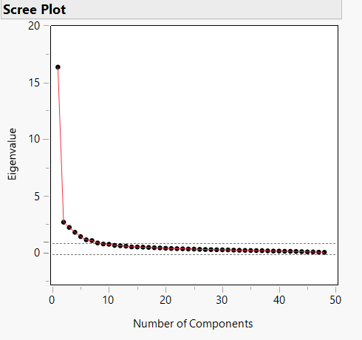

Number of factors = 8

b. What are the values of the eigenvalues and percentage of variance accounted for by the latent constructs. Provide an interpretation of these numbers.

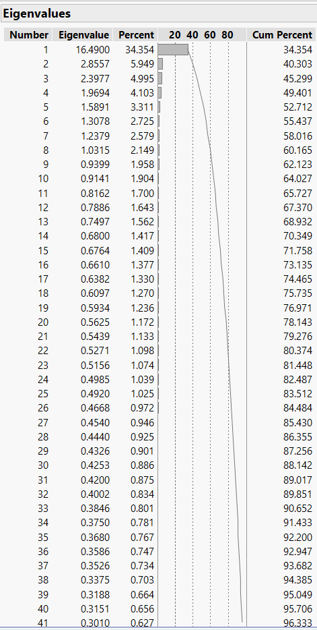

c. What are the values for the factor loadings?
- Interpret these numbers.
- Identify any problematic loadings and any cross-loadings.

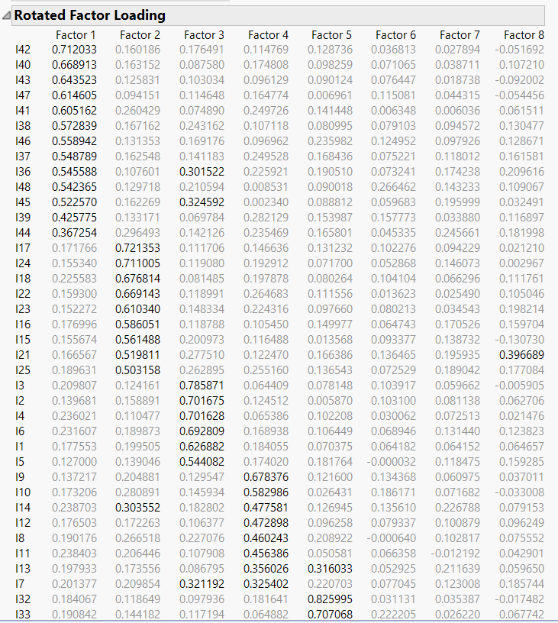

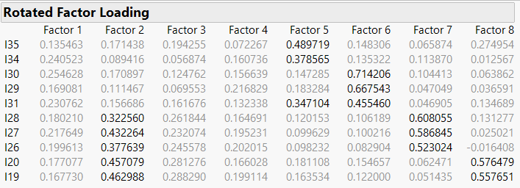

d. How many factors should we retain?
- What is your substantive interpretation of the factor(s)?

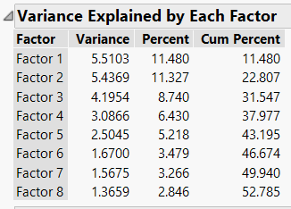

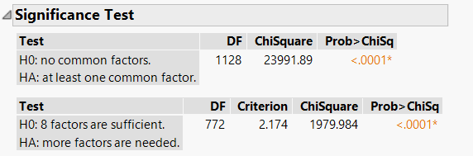

e. Conduct an item analysis for each factor that you retained. Are all items functioning appropriately? If not, describe your decisions to refine the instrument.

f. Identify the factor with the lowest reliability (i.e., lowest Cronbach’s alpha value). How many items would you need to add to this factor to ensure a Cronbach’s alpha value of at least 0.90?

Cut/paste and annotate your solution to this assignment in ms word using the mini-project guidelines addressed in the syllabus.

